PSA, Inc.

Wireless 9000

Desktop

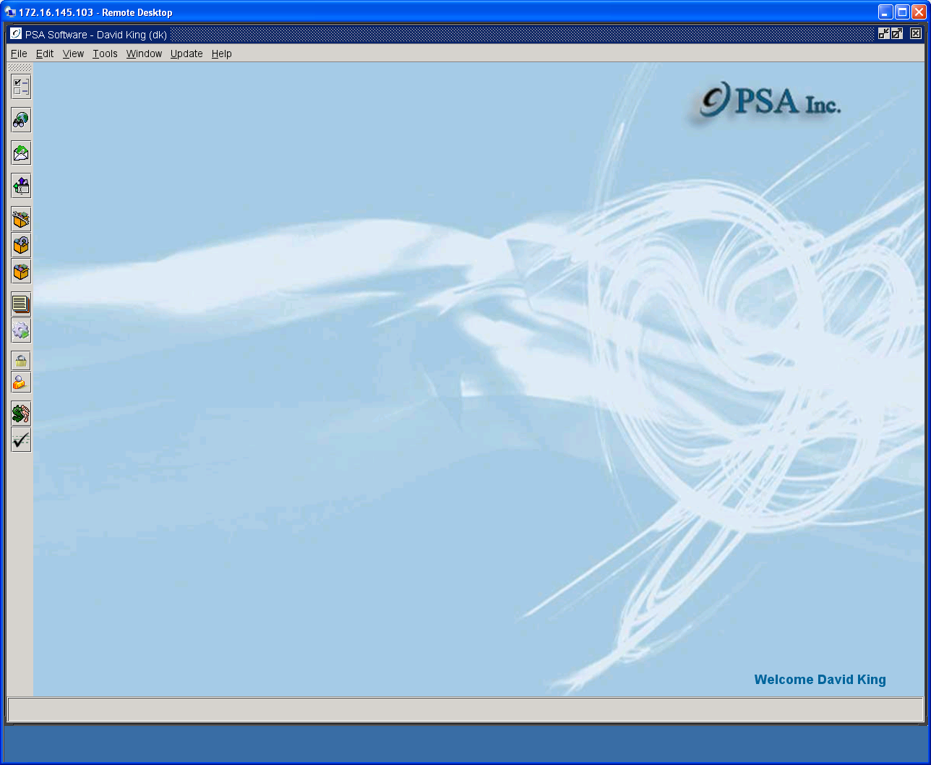

Reports

Table of Contents

Create Reports 3
Output Options 5
Saving as CSV 7
Emailing a CSV File 9
Large Reports 10
Remote Reports 13
Test Bill Creation 16
Archived Reports 19
Retrieval by Date Range 20

Create Reports

Allows users to create, view, print or export reports to a file.

To display reports available in Desktop, open reports and click on the ‘+’ beside the various sections. There may be multiple selections in each section. Highlight the report to be created and a selection screen will display. Some reports require no input for creation. Most reports will have parameters that will define the report. If there are required parameters, the fields will be provided. Enter information into the fields and press View Report. If there are no fields displayed, press View Report.

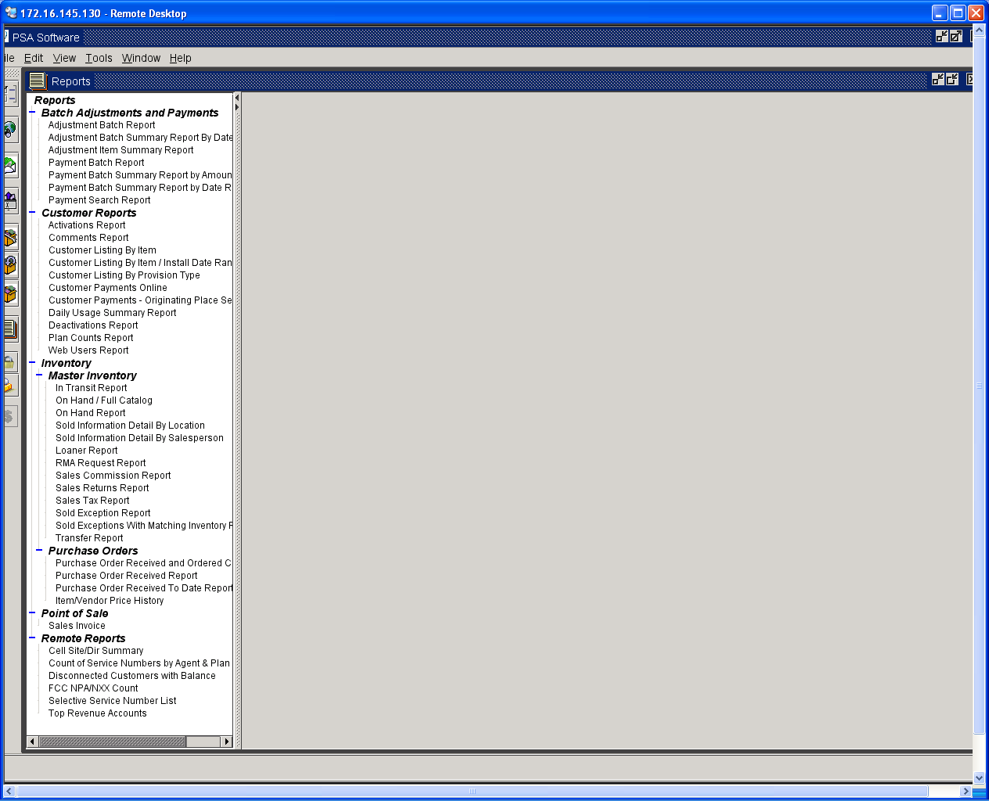

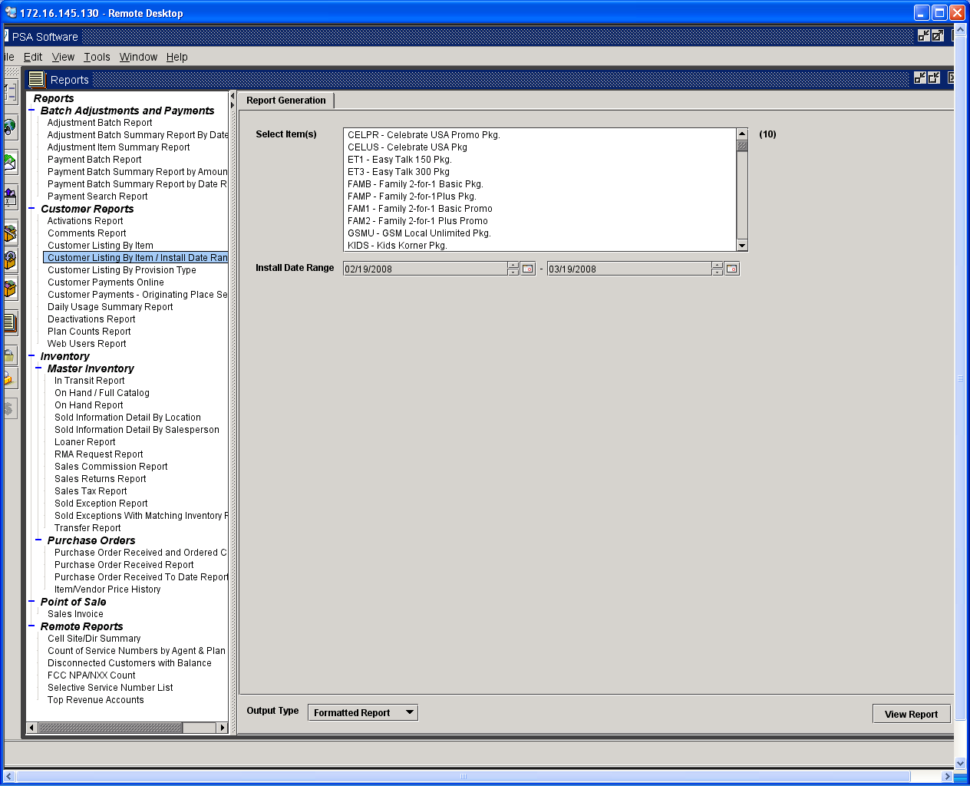

Reports are defaulted as formatted reports and displayed in the same screen, but they can be changed to CSV files (information follows on CSV reports).

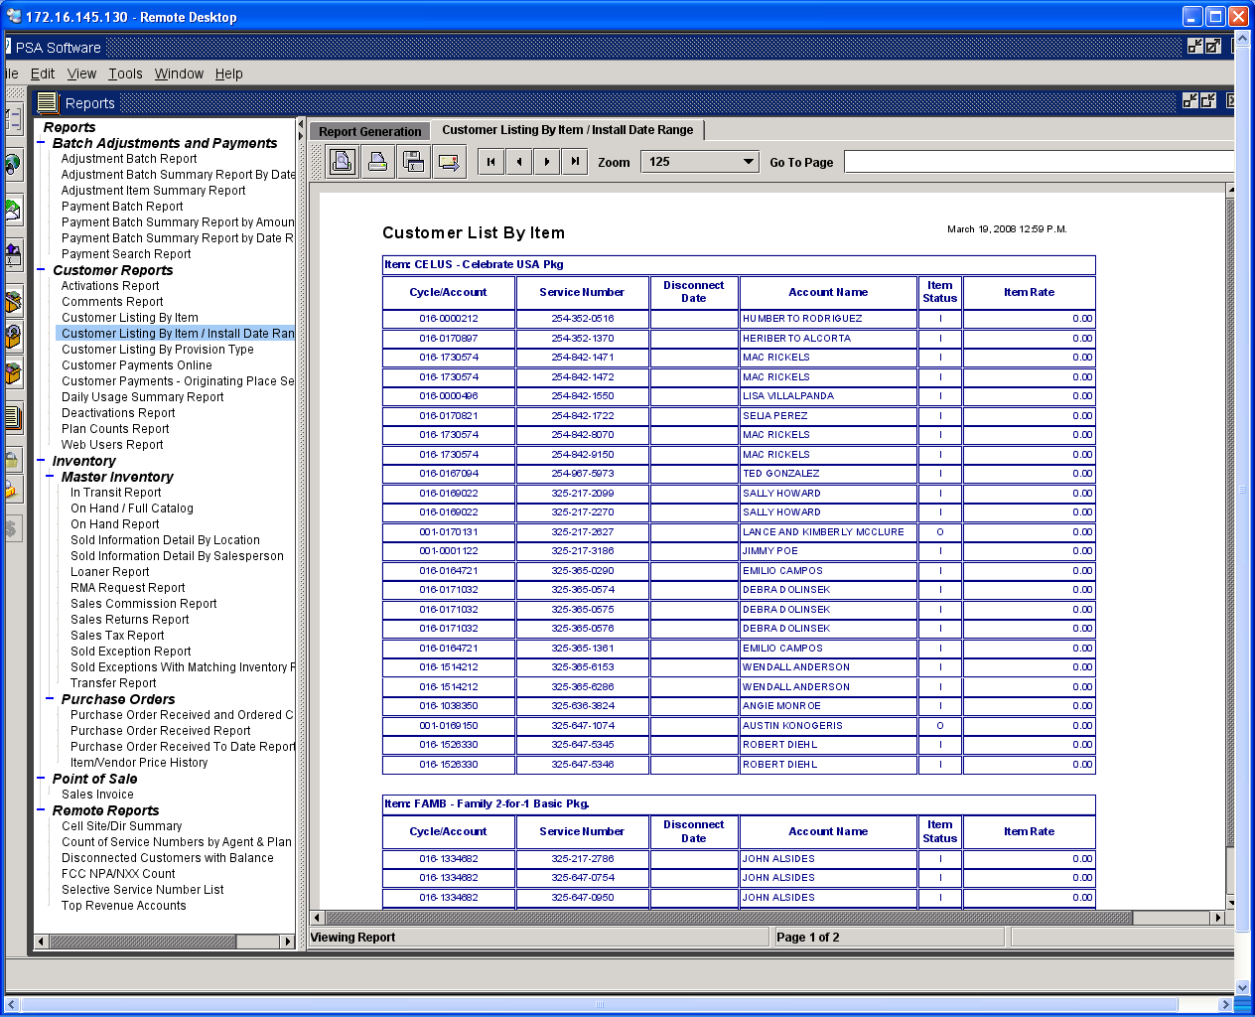

Output Options

There are various way to handle the report once it is generated.

First Printer Icon 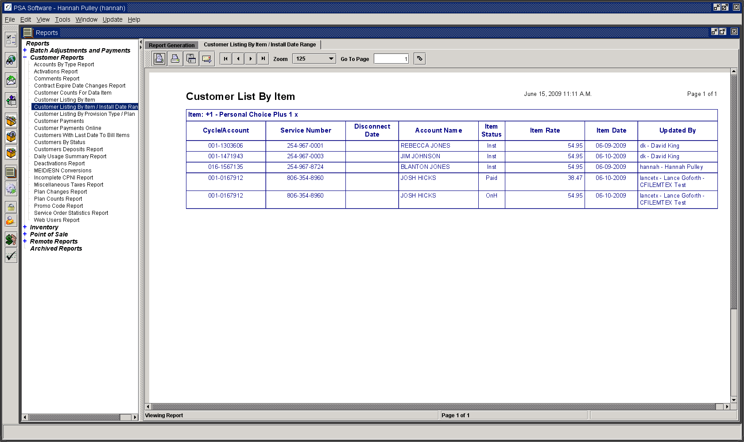 – displays a printer dialog box and allows the user to select the printer.

Second Printer Icon – prints immediately to the user’s default printer.

Export Print to File Icon – Allows you select the folder to store to, name the file, and select how the report should be saved. Select the folder to save to, name the file, and select file type of how you would like the report saved. Types of save – Adobe PDF opens with Adobe , Rich Text Format (RTF) opens in MS Word, Plain Text, Portable Networks Graphic Image good with Web pages, TIFF image (TIF), PCL Printer file, Encapsulated Post Script (EPS), Adobe Postscript (PS), HTML which loads well into MS Excel.

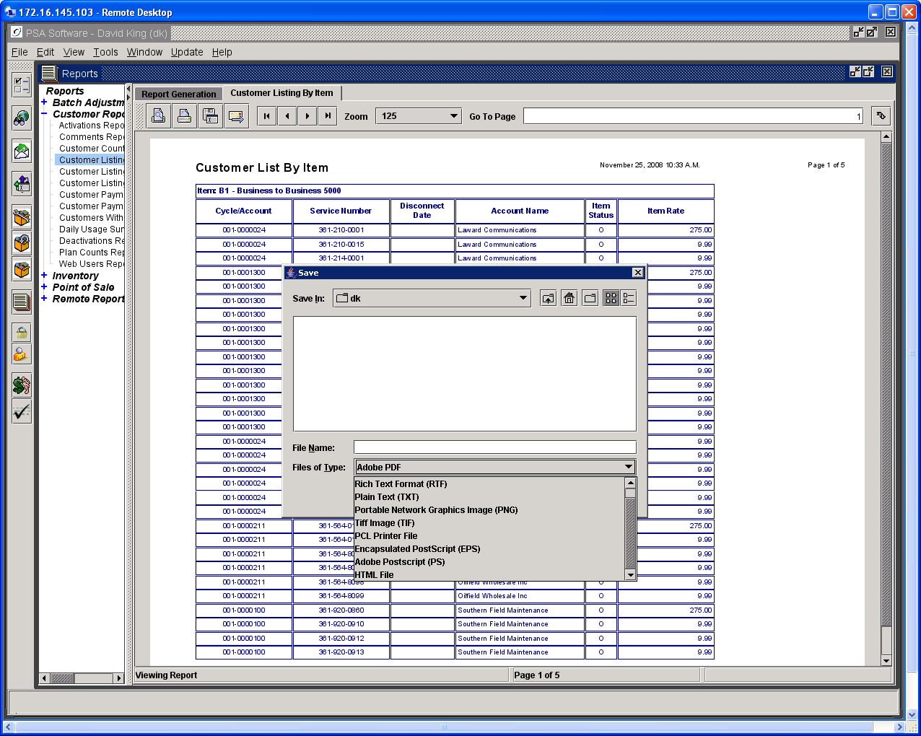

Send Email Icon – pops up a dialog box allowing the user to email the report. The email has a subject line and message box to explain the report and can be sent as PDF, Rich Text, HTML, Plain Text, etc.

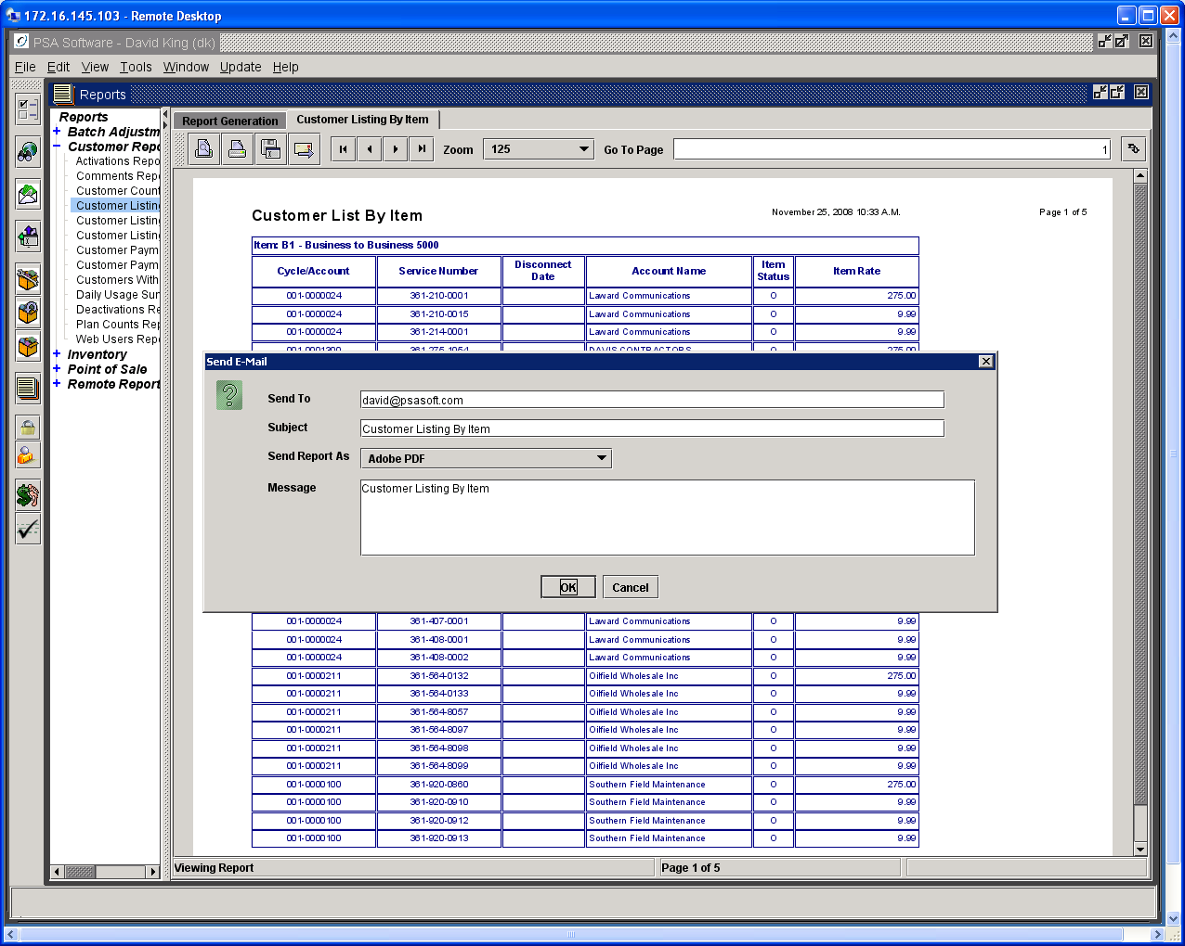

Additional controls consist of: Return to First Page Arrow, Back One Page Arrow, Next Page Arrow, and Last Page Arrow. Home, End, Page Up and Page Down on your keyboard are also functional.

The zoom function is set from 25% to 300% of image. Other selections: Fit Window loads the largest image for one page per frame. Fit Width expands the image where the width fills frame and the length is scrollable.

Go to Page box allows you to move to a specific page. Enter the page number in the field and press the icon immediately to the right to move to that page.

CRTL L changes the layout of the display. The default is one page per frame. The second instance moves all of the pages to one frame and allows the user to scroll through the entire document. Third instance loads pages two per page. Fourth instance returns to default one page per frame.

Saving as CSV

Another way to deliver a report is to use the Output Type dropdown in the lower left. Select all the criteria and change the Output Type to CSV (Comma Separated Value) from the dropdown.

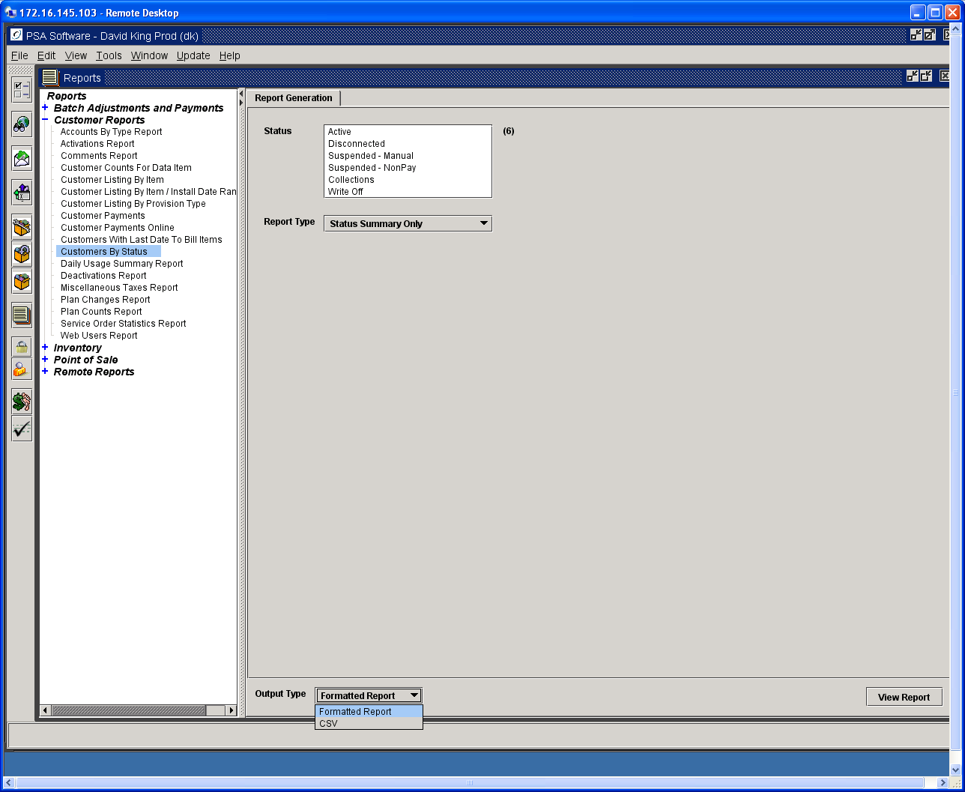

As the report is being generated, you will be asked for additional information.

To save to file, mark Save to File and press the Select File button. A pop-up will ask where you want to save the file and a name for the file. Press Select when you have entered the information. If you have Microsoft Excel installed on your Remote Terminal or PC, you can mark the Launch in Excel check box. The file will then be opened in Excel for editing. Press Save to complete the report.

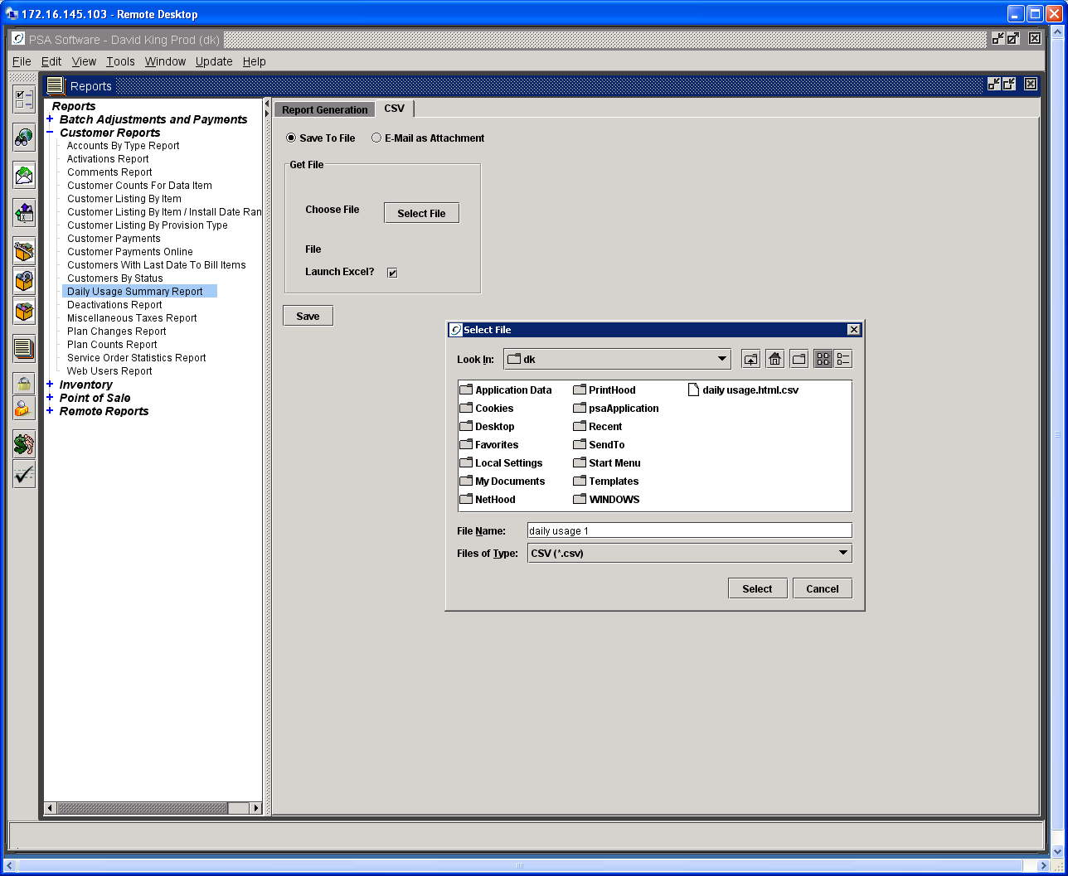

When the report is created you will receive notification.

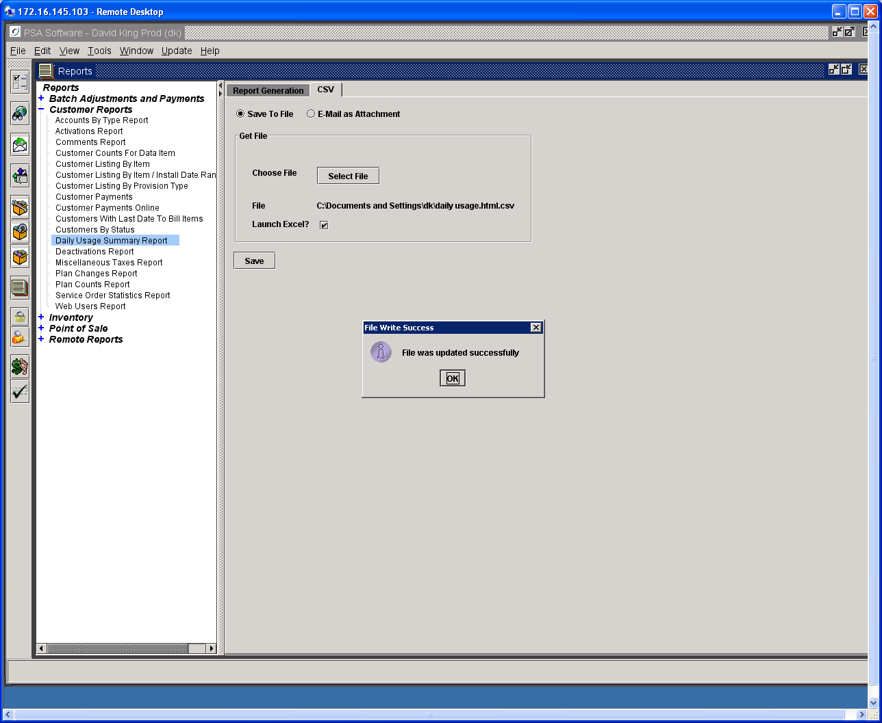

Emailing a CSV File

Change the Output Type to CSV at the bottom- left of the Report Generation screen. Next select E-Mail as Attachment.

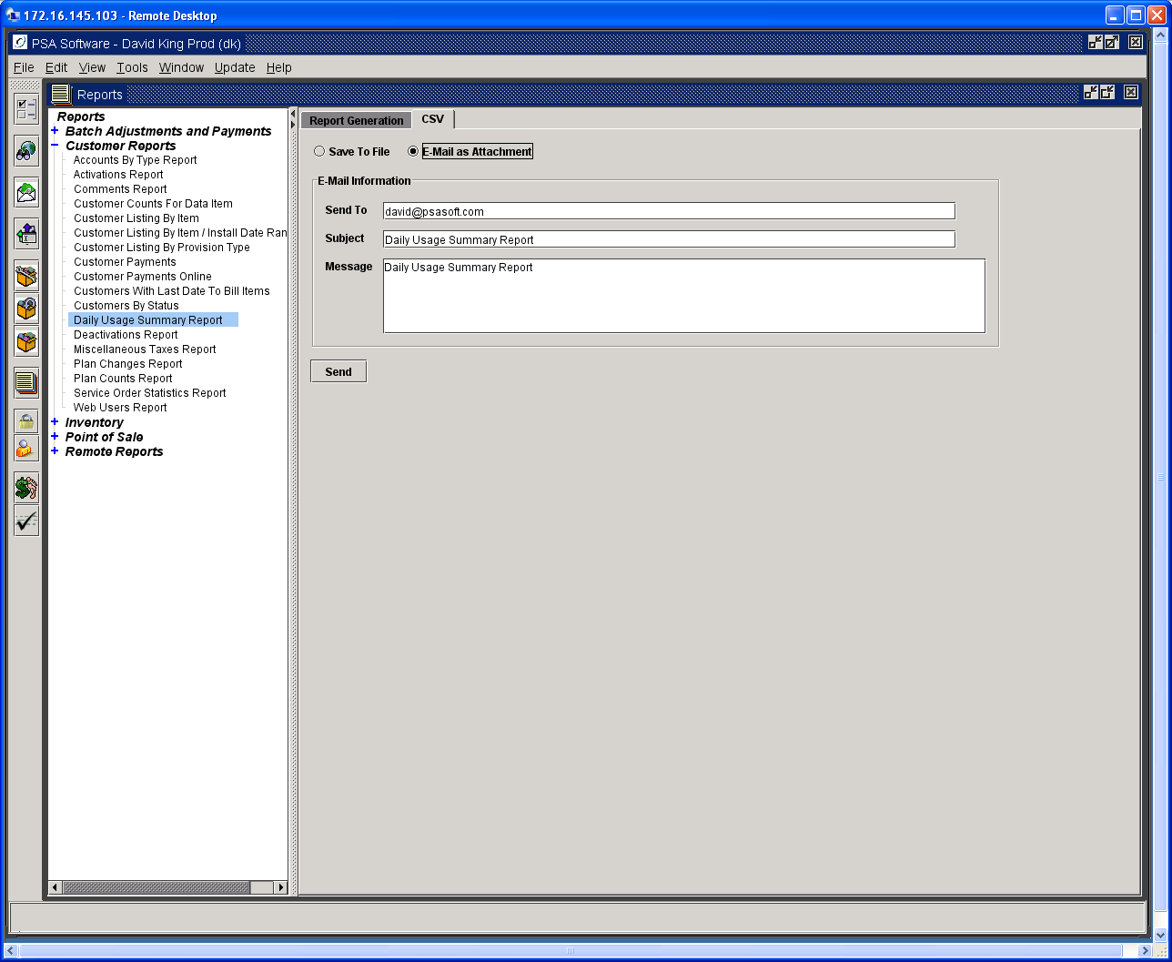

Enter the required information and press Send.

Large Reports

If a report is too large to display within the client you will be given the option to Return Report or Email Report.

Return Report Option
This allows the report to be created and then formatted to display in other programs such as Adobe Reader. HTML will be displayed in your browser. If you select HTML you can copy the report from the browser using the Select All and copy to an Excel spreadsheet. This will require some formatting once the report is loaded in Excel.

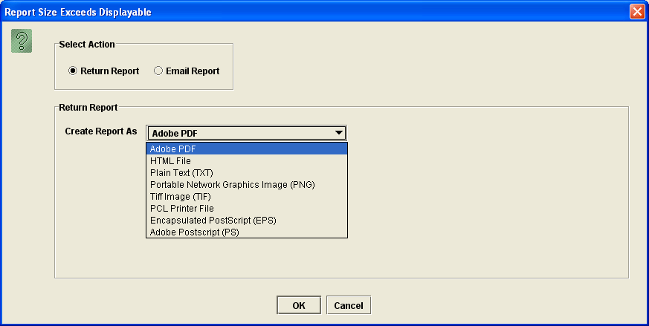
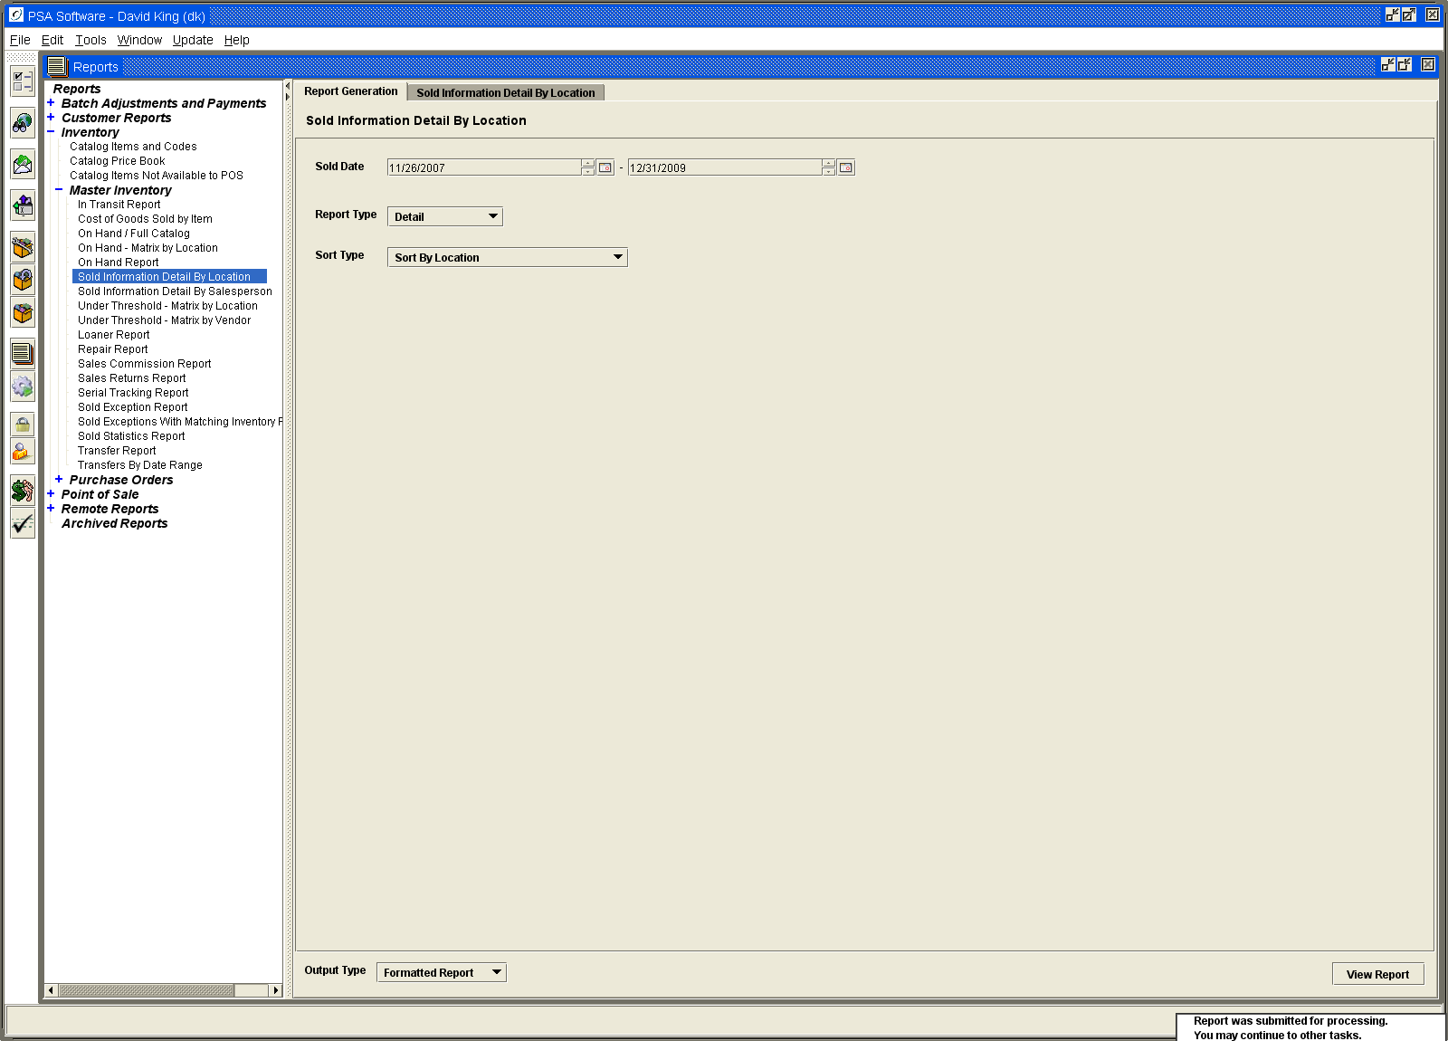

The second option is to email the report to yourself or someone.
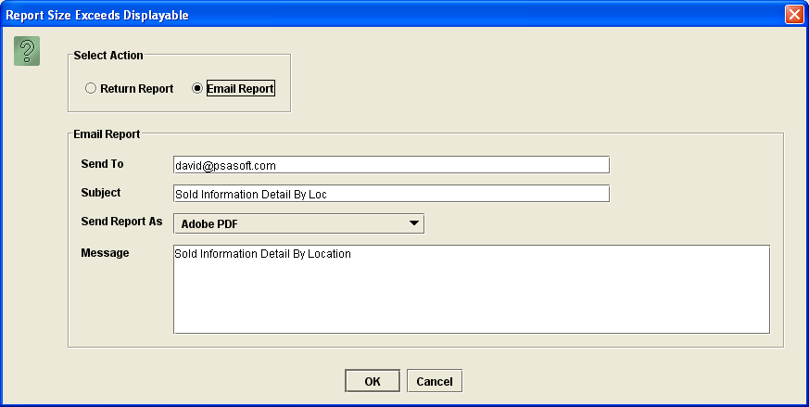
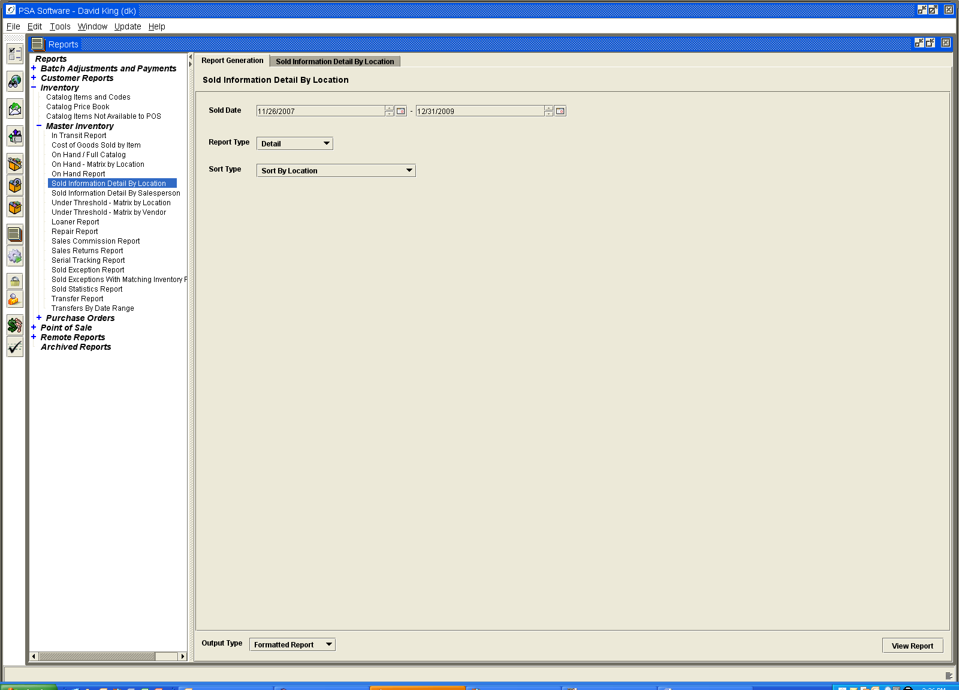

You have the option of changing the addressee, subject, file type and the message content. When you have made the necessary changes press OK and the report will be emailed.

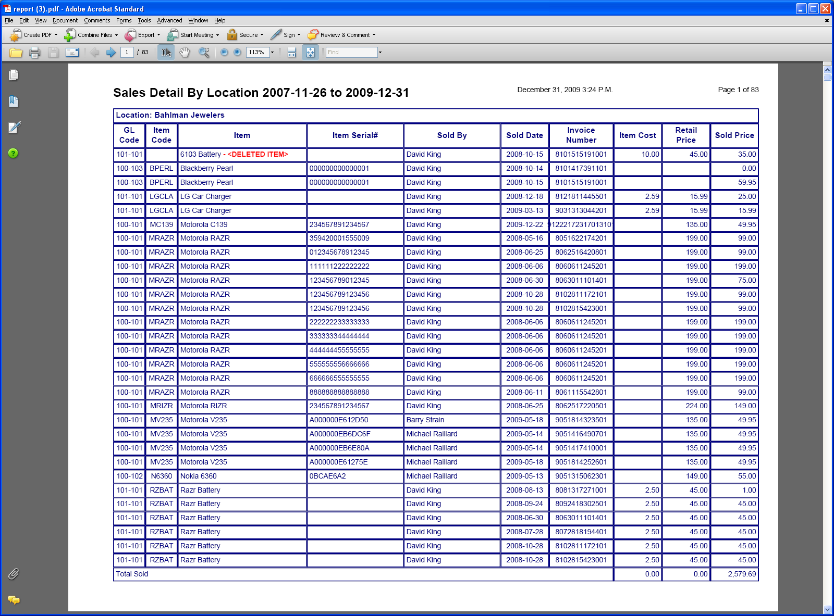

You may email it as HTML. Then save the file as HTML somewhere on your PC. Then highlight the file and right click and find Open With select Excel to load the file into the spreadsheet.

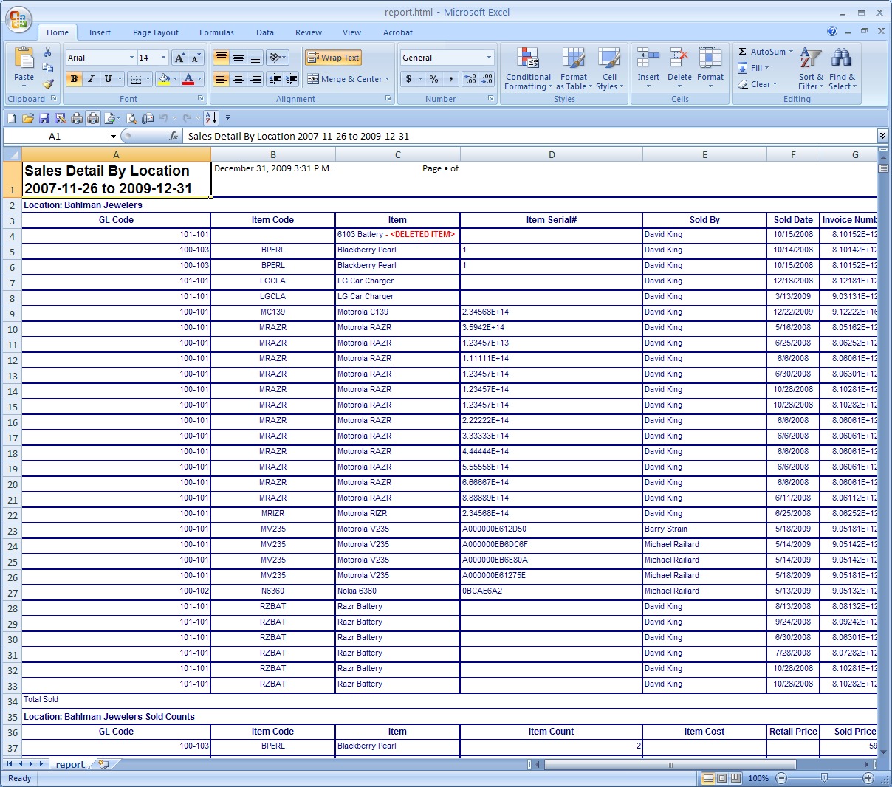

Remote Reports

These are reports that are run on the iSeries server rather than application server. These reports are handled on a one-by-one basis. If you have a report that you run from the green screen and would like to see it moved here, please contact PSA. These reports are handled differently in regards to display and access.

The section at the top of the display shows a drop down for previously run reports under the User ID that is signed on to the current session. If you have authority and need to see reports run by alternate User IDs, then put a check in the Include All Users box. Select the report from the drop down and press View. Refresh will update the reports available in the drop down box. Remote reports have a date and time stamp following the name of the report. If there are multiple instances of a report, use the date and time stamp to locate the correct report.

To run a remote report, select the report and enter the appropriate parameters. Press the Submit button to create the report. These are usually larger reports and may take some time to run. You can press Refresh periodically to see if the report has completed. It will not automatically display on the screen. You must select the report from the drop down with the correct date and time stamp and press the View button.

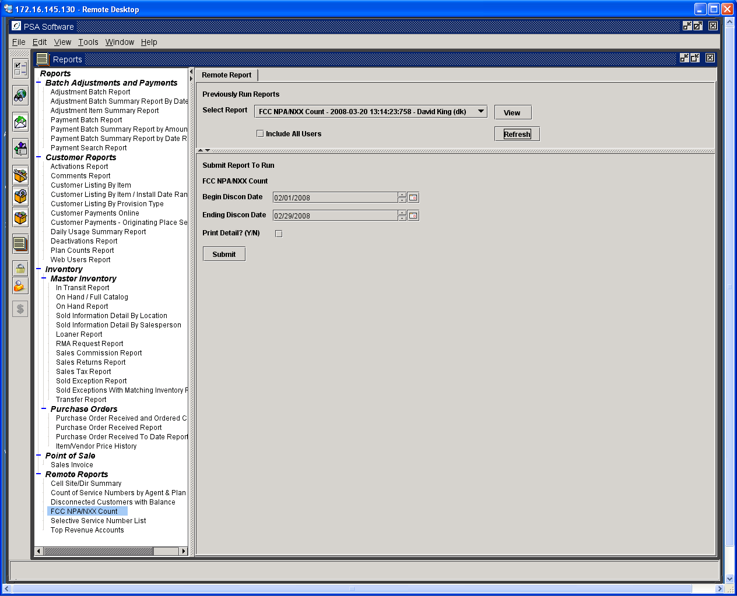

In the event that a report is too large to display, the email program will automatically be displayed. The report can be sent to the default email shown or it can be changed to another address. You may send the report to multiple addresses; use a comma to separate the email addresses. Press Ok to commit the report to email.

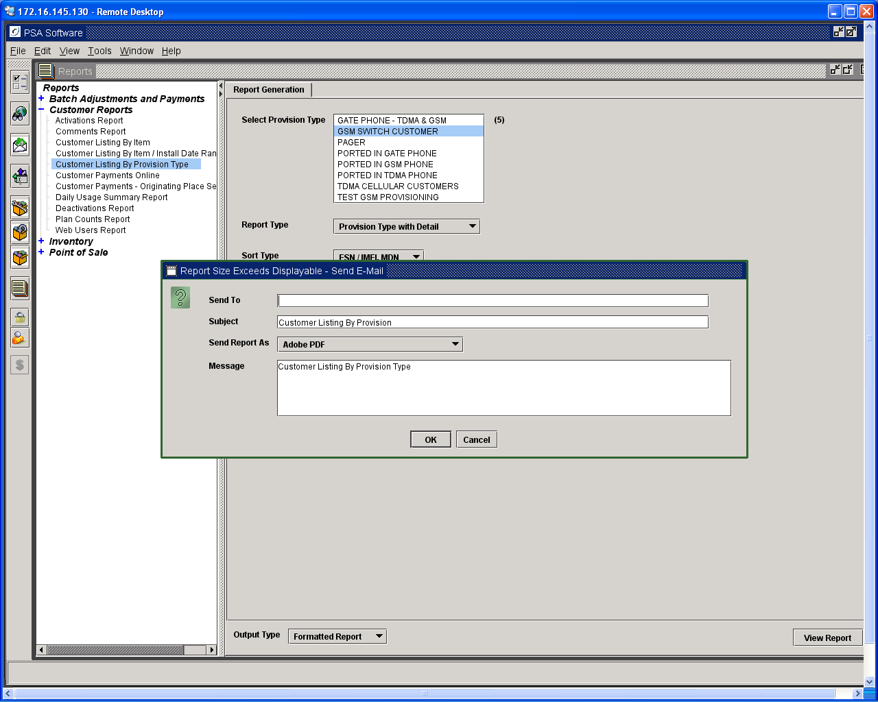

The system will notify you with the following message to let you know the report is being generated.

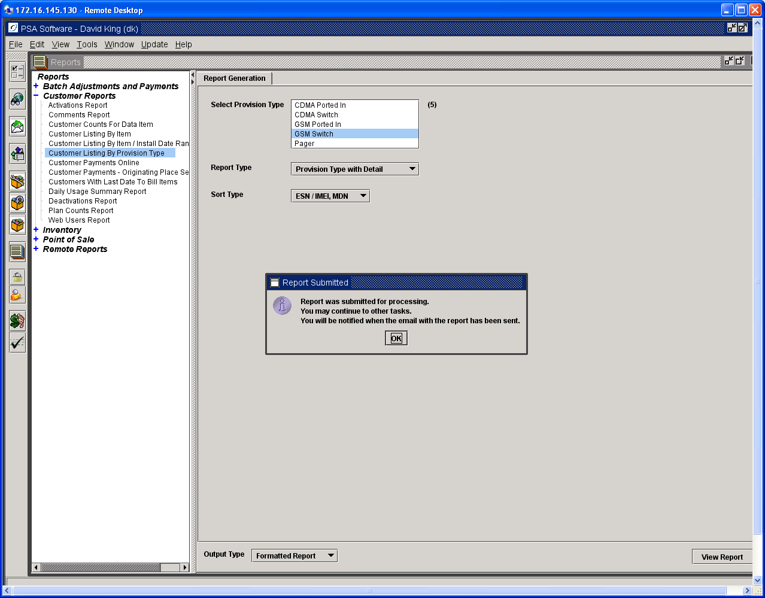

As the message text says, you may go with other tasks; the report has been transferred to the iSeries for processing and emailing. Once the report is generated and sent via email; you will see the following confirmation:

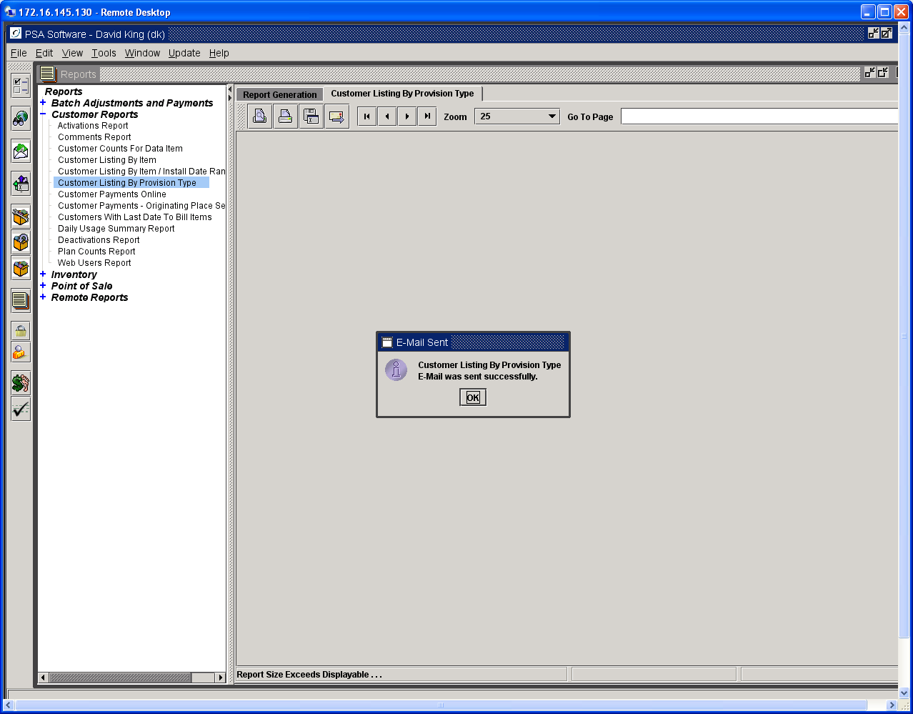

Press OK to clear message. Check your email periodically for the report. The report will be a PDF attachment. You may view or print the report from there.

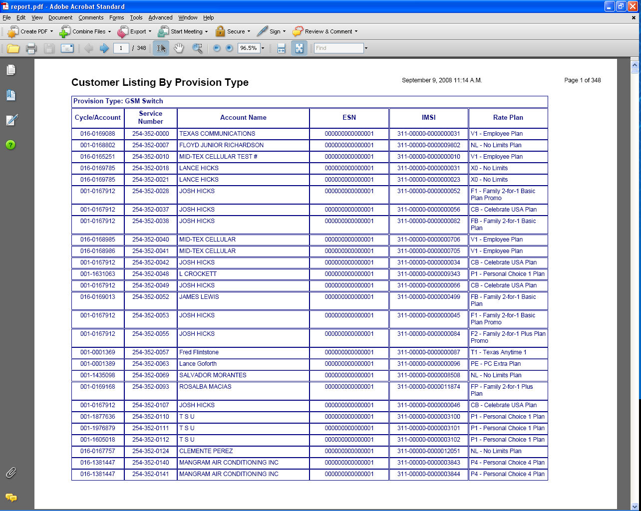

Test Bill Creation

PSA has created a function in the Report Module to run a test bill for accounts in our system. This only creates a text bill for verifying charges, it does not create anything to send to OSG. The format is the text- only statement seen in the Customer Care, Report, and Bill Image. The program that creates this image is the same as the programs in the billing run. The numbers should be accurate for checking new plans or other changes.

To run this report, open Remote Reports. You will see an option titled: Run Test Bill for Selected Account. Select this option; it will open a screen asking for company, cycle and account number. You will need to know the account number due to the way this interacts with the back end system. There is no search function on this option.

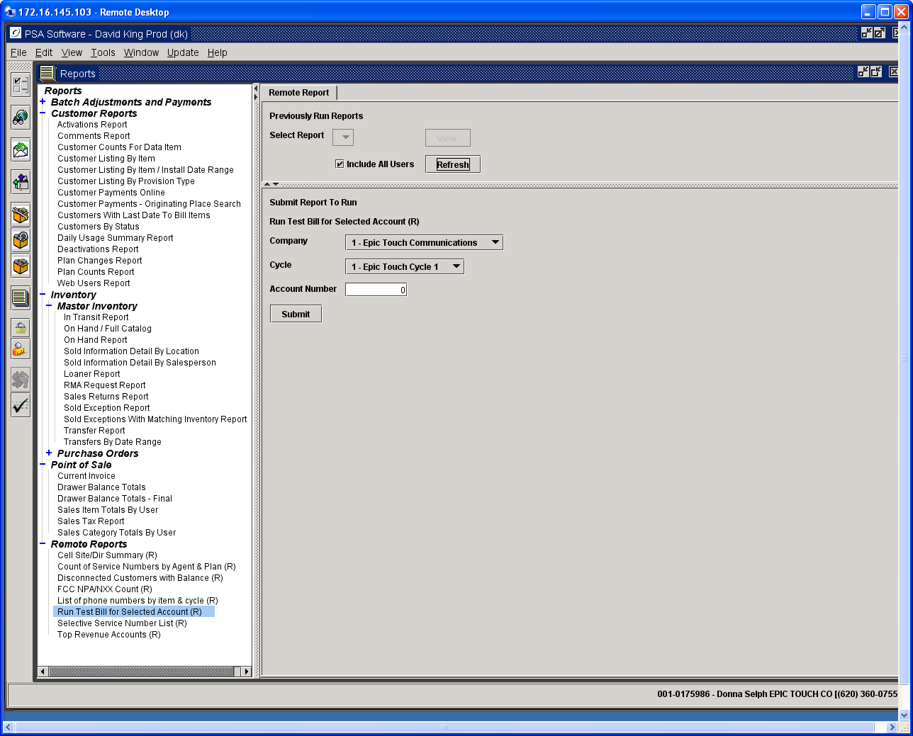

Select the cycle and enter the account number, then click Submit. It takes a couple of minutes to run; larger accounts may take considerably longer as the number of calls to be rated is potentially much higher. Then you can go to your Customer Search. Find the account you ran the bill for, and double click on it to open. Go to the Reports tab, and select Bill Image Inquiry. Then click View Report. This pops up a box asking for bill date / run / sequence. It will default to the most recent entry. You will look for one for the current bill date, run = Test Bill and then a sequence number (normally you’ll want the latest one). You can run this for an account any number of times, so the sequence just increments each time.

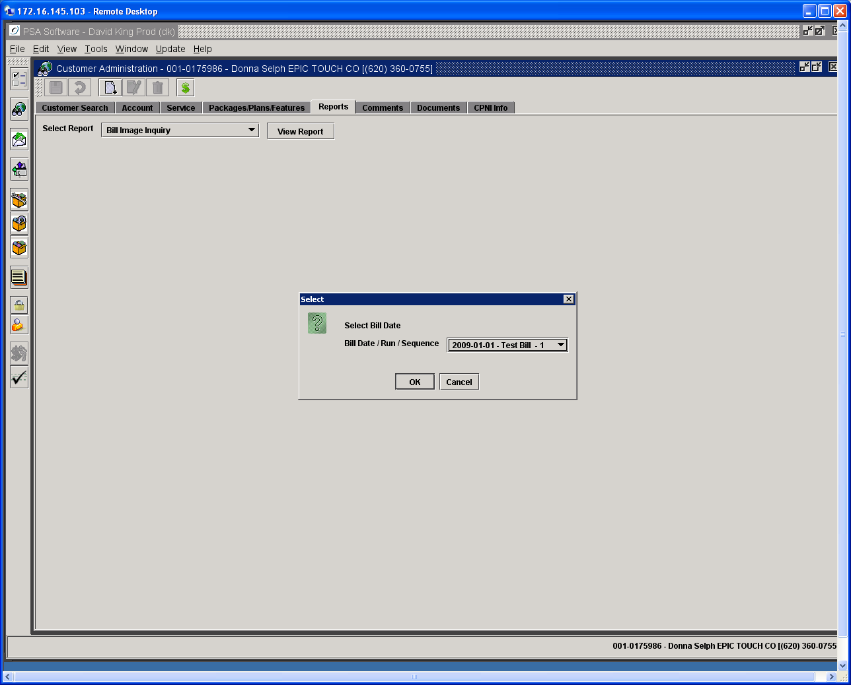

Click Ok after selecting the bill run to view and that will display the bill.

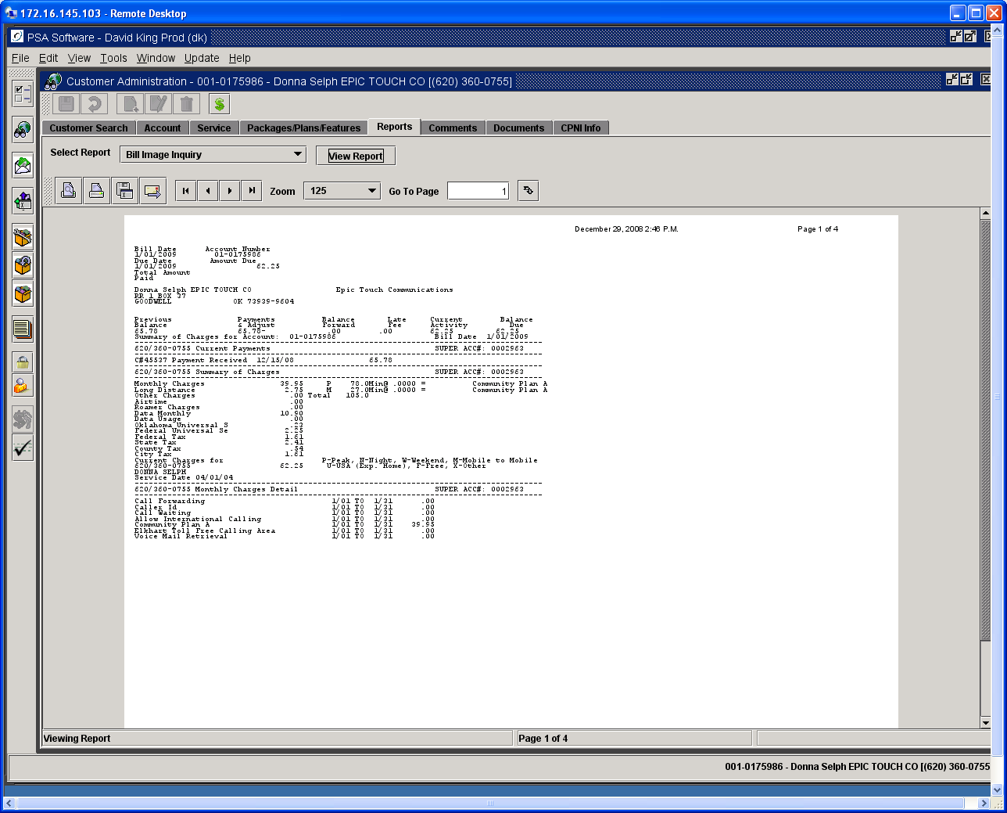

Archived Reports

These are reports selectable by a company that will be saved for future reference. Reports are generated from various sources such as manual report requests to the batch that are printed with the billing runs. These reports are saved each evening and compressed for storage. When you request an archived report, the report is located, uncompressed and displayed in the viewing area. Some reports are too large to display in the panel so you will receive a request to email the report. Some reports will take more time to retrieve than others due to the size of report.

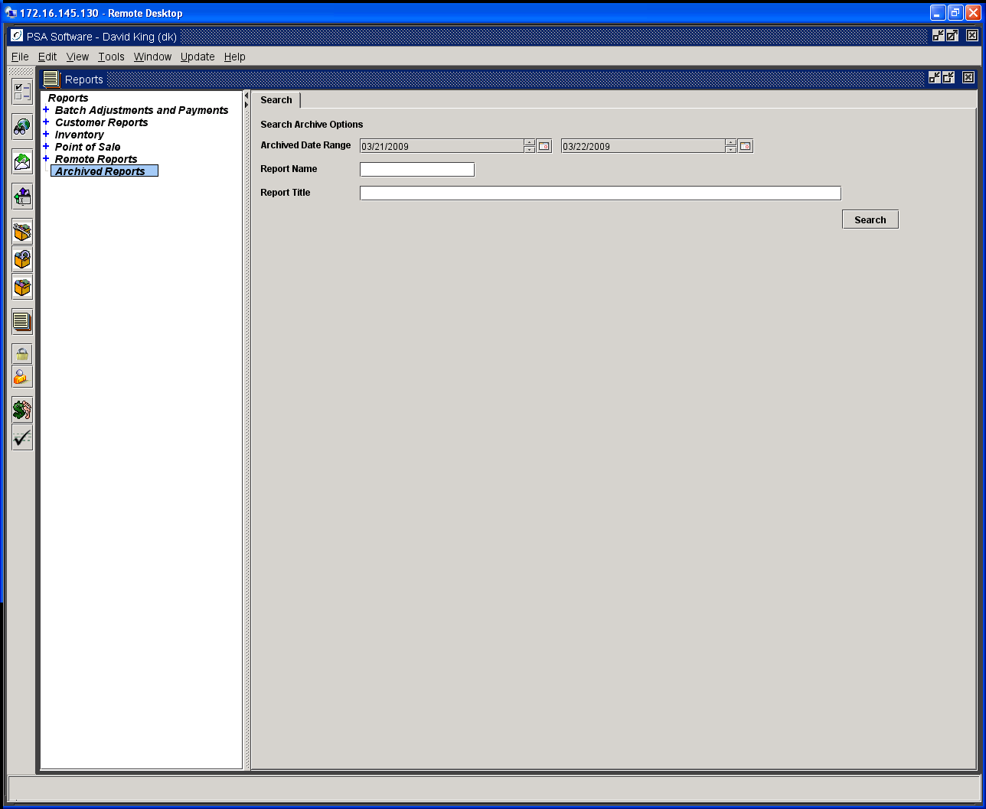

To locate the various reports, use the selection criteria displayed.

Archived Date Range – this will locate all reports that were archived between, and including, the dates selected.

Report Name – this is the program report name. Examples would be CB1028 which is the G/L Edit report from the billing run. This will select for display all reports with this Report Name.

Report Title – allows you to select only reports with the specific title.

You may use multiple criteria to find the report you need. Example: set the date range for a specific time period and then add the Report Name.

Retrieval by Date Range

This displays each included day in the tree. Press the + sign to open the day.

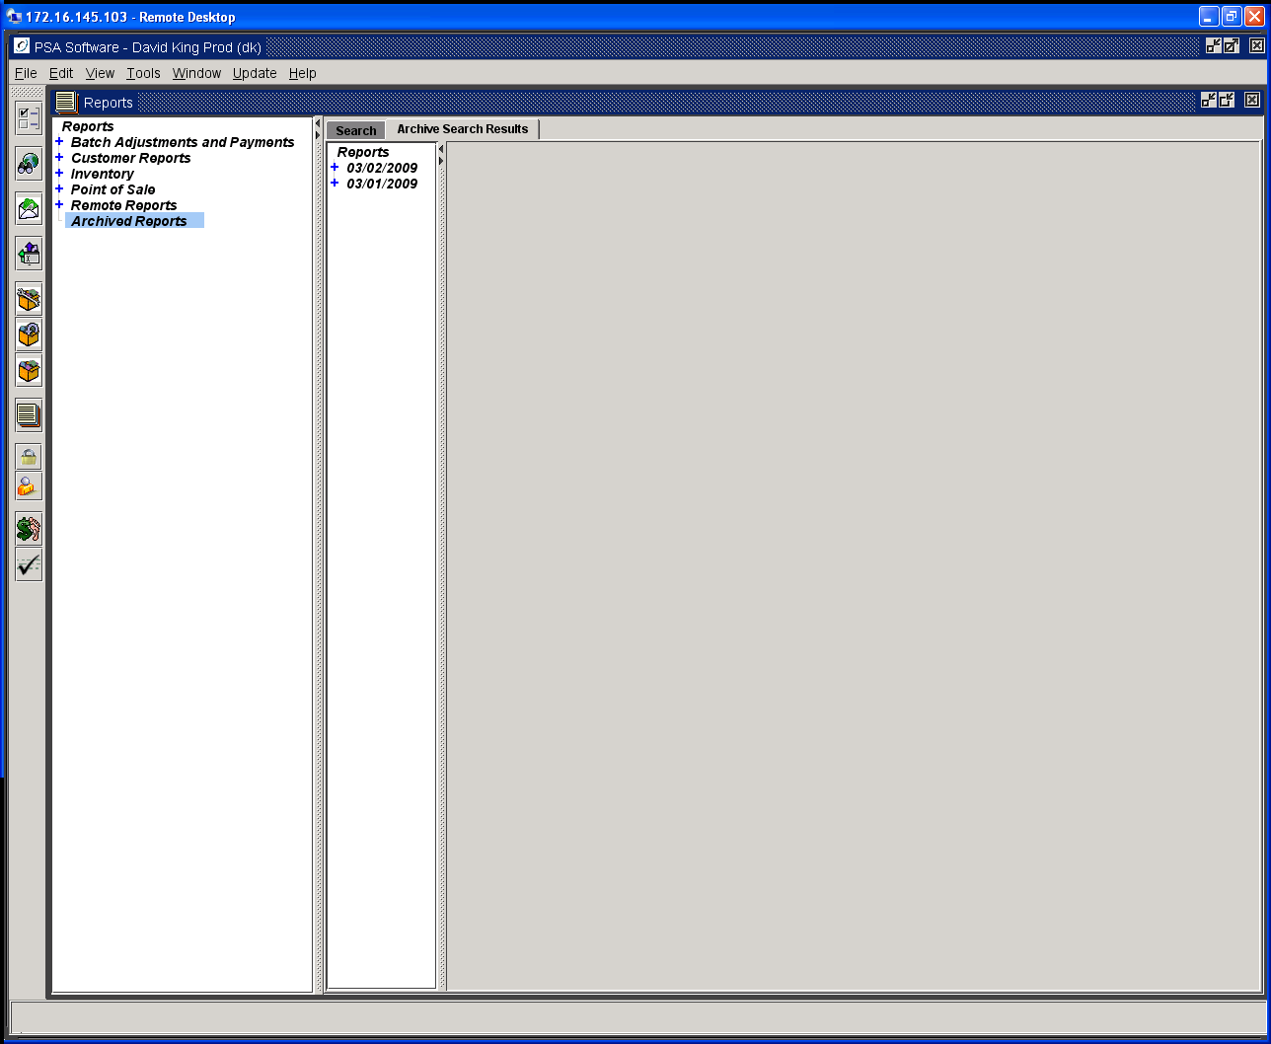

Click the report you want to view.

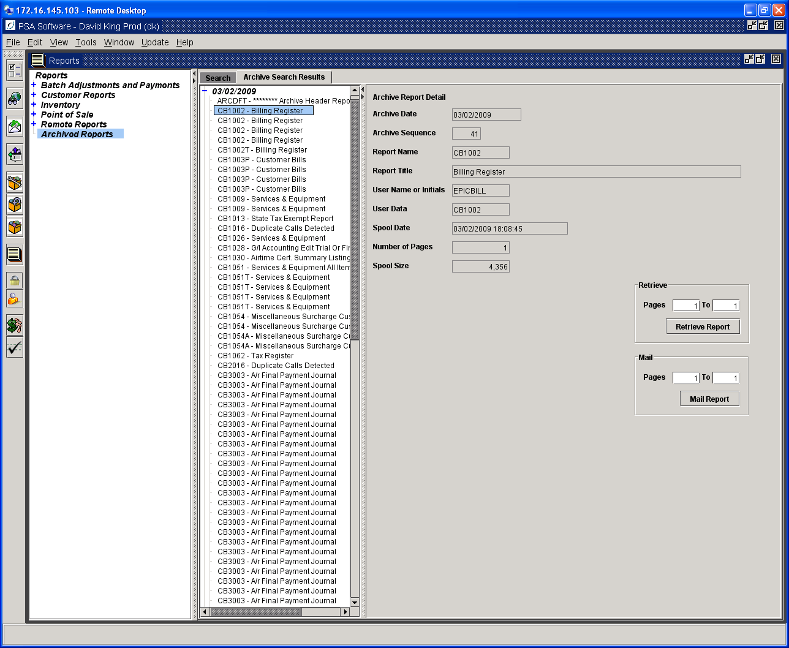
Pressing Retrieve Report will display the report in the report viewer. If the report is too large to print as a single report you will need to view the report in sections. The length of the report is displayed in the Number of Pages field. Only 200 pages can be viewed at one time. In the Retrieve sub-box, enter in the page numbers you want to view. If the report is 484 pages long, and you enter 1 To 200 in the Retrieve box and press Retrieve Report, the first 200 pages of the report will display. You can then go back and enter in pages 210-400; and then 401-484.

The same principles apply to Mail Report, except that the report is emailed rather than shown on the desktop. Large reports may need to be emailed in increments also, depending on the server size.

